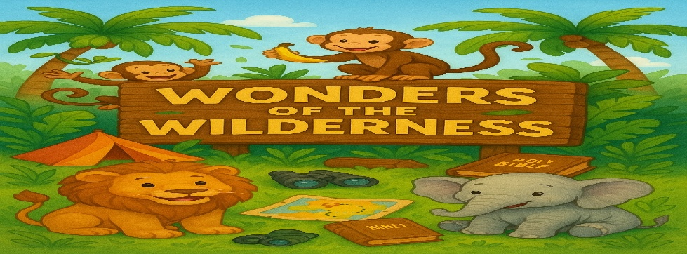
School Sized bag
1 Box of Jumbo Pencils & 4 Jumbo Crayons boxes
1 Ruled Noted Book* (Please label)
3 Ream of White Copy Papers
4 Black Dry Erase Makers & Small Dry Erase Board*
4 Container of Clorox wipes & 4 Cans of disinfecting spray
4 Box Baby Wipes & 4 Boxes of Kleenex Tissues
2 Box Gallon-Sized Zipper Bags (do not label)
2 Box Quarter –Sized Zipper Bags (do not label)
Cover Blanket & Flat or Crib Sheet* (For Nap Time)
Change of Clothing with Under Pant*(Please label)
1 Watercolor Paint Set & 1 Art Smock* (Please label)
1 Box Playdough & I Pack of Construction Papers
Personalized bottled water
1 bag of Cotton balls. (Dollar tree)
1 pack of paper plate (Non-Sectional) Dollar Tree
2 Teacher/Parents Communication Folders & Field Trip T-Shirt (Purchased at the School)
***Please label every item with Asterisk with your child’s name***

