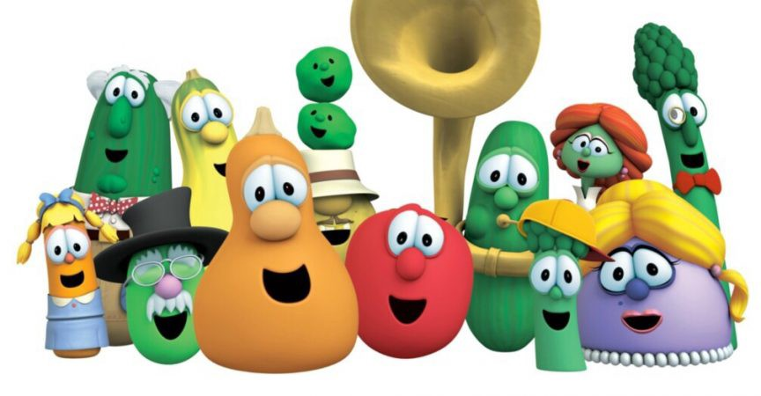
We Are the Big Idea!
Toddler/Young 2s Room Supply List
2 Teacher/Parents Communicator Folders (Purchase at the school)
School Age Backpack*
Family Picture
3 Box of Jumbo crayons & 1 Large pencil box*
2 Ream of White Copy Paper
2 Elmer’s Washable Glue
4 Boxes of Kleenex & 3 Baby Wipes*
2 Boxes Gallon-Sized Zipper Bags & 2 Boxes Quarter –Sized Zipper Bags (do not label)
3 Containers of Clorox Wipes
Cover Blanket & Flat or Crib Sheet* (For Nap Time)
2 Cans of Disinfecting Spray
A Full Change of Cloth & Art Smock*
Diapers/Pull Ups*
2 Pack of Construction Papers
Field Trip T-Shirt (to be purchased at the school)
*Please label every item with Asterisk with your child’s name. NB: No baby bottle please.

