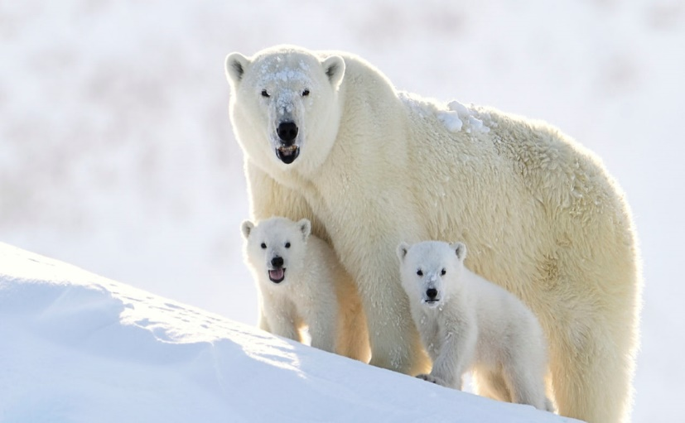
The Polar Bears PRE-SCHOOL 2 YEAR SUPPLY LIST
2 Teacher/Parents Communicator Folders (Purchase at the school)
School Age Backpack*
3 Box of Jumbo crayons
1 Box of Jumbo Pencils & 1 Large pencil box*
2 Ream of White Copy Paper
2 Elmer’s Washable Glue
4 Boxes of Kleenex & 3 Baby Wipes*
2 Boxes Gallon-Sized Zipper Bags (do not label)
2 Boxes Quarter –Sized Zipper Bags (do not label)
4 Containers of Lysol Disinfectant Wipes
3 Cans of Disinfecting Spray
Cover Blanket & Flat or Crib Sheet* (For Nap Time)
Change of Cloth: A Shirt, Pant, underwear and socks. (Please label)
1 Watercolor Paint Set & 1 Art Smock*
1 Box Playdough
Clothes Pin & White Cotton Balls (Dollar Tree)
I Pack of Construction Papers
Field Trip T-Shirt (to be purchased at the school)

